|  |
| --- |
| **E-Commerce Website Using Django**  **Using Django** |
|  |

|  |
| --- |
| 2021-2022| By: Soham manjrekar, Aadarshkumar Sharma , Mohammed Baquir Sayed, Suchit Prashant Sawant |





Rizvi College of Engineering

Department of Computer Engineering

Mini Project Synopsis Report

on

**E-Commerce Website**

Submitted in partial fulfilment of the requirements

of the Mini-Project 1B of Second Year of

Bachelors of Engineering

by

Soham Shrikant Manjrekar (UIN:201P018)

Aadarshkumar Sharma (UIN:201P026)

Mohammed Baquir Sayed (UIN:201P055)

Suchit Prashant Sawant (UIN: 201P040)

………….……………………………………………..

Guide:

Prof. Anupam

University of Mumbai

2021-2022

**ABSTRACT**

In today’s fast-changing business environment, it’s extremely important to be able to respond to client needs in the most effective and timely manner. If your customers wish to see your business online and have instant access to your products or services.

Online Shopping is a lifestyle e-commerce web application, which retails various fashion and lifestyle products (Currently Men’s Wear). This project allows viewing various products available enables registered users to purchase desired products instantly. This project provides an easy access to Administrators and Managers to view orders placed.

In order to develop an e-commerce website, a number of Technologies must be studied and understood. This is a project with the objective to develop a basic website where a consumer is provided with a shopping cart application and also to know about the technologies used to develop such an application. This document will discuss each of the underlying technologies to create and implement an e-commerce website

Online Shopping play a great importance in the modern business environment. La BELLE Fashion Store has opened the door of opportunity and advantage to the firms. This paper analyzed the different issue of online shopping. The research aims to provide theoretical contribution in understanding the present status of online shopping. The Study Discuss the consumers’ online shopping behaviors. Paper also identifies the problems face by the consumers when they want to accept internet shopping. Present paper is an expressive study based on the detailed review of earlier pertinent studies related to the various concepts of online shopping to discover the concept of online shopping. Solitude and safety risk emerge regularly as a reason for being cautious about internet shopping. Shopping convenience, information seeking, social contact, and diversity affects the consumer attitude towards online shopping. The impossibility of product testing, problems with complaints, product return and missus of personal data are the main doubts regarding on-line shopping

**Keywords:** Python, Django, MySQL, CSS, HTML, JavaScript, ecommerce, Bootstrap 3,

Certificate

This is to certify that the project synopsis entitled “E-commerce website” has been submitted by Soham Shrikant Manjrekar, Aadarshkumar Sharma, Mohammed Baquir Sayed and Suchit Sawant under the guidance of Prof. Anupam in partial fulfilment of the requirement for the award of the Degree of Bachelor of Engineering in Computer Engineering from University of Mumbai.

Certified By

Prof. ____________

Prof. ______________

Project Guide

Head of Department

Prof. ____________

Prof. ______________

Internal Examiner

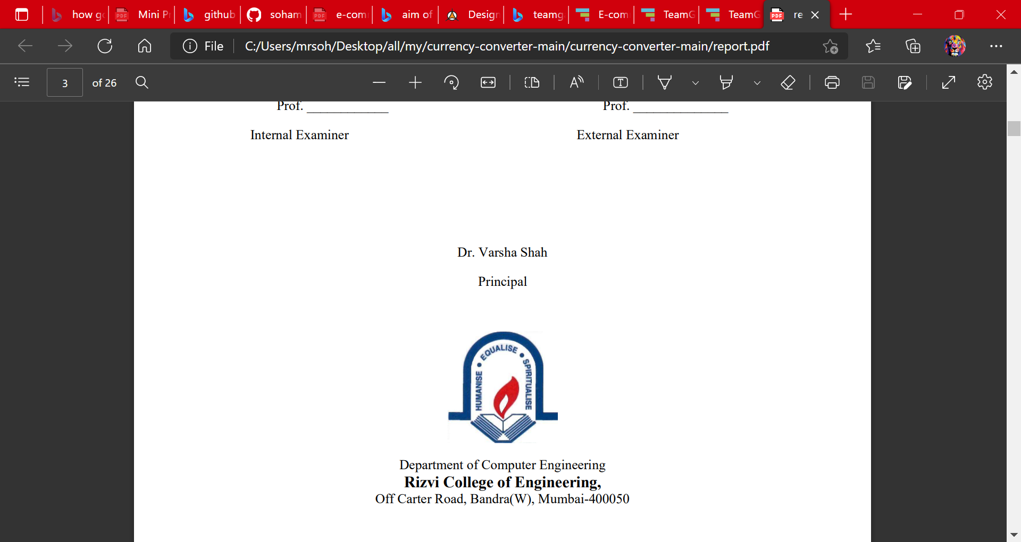External Examiner

**Index**

**Sr. No Title Page No.**

1. INTRODUCTION………………………………………………………2

1.1. AIMS AND OBJECTIVES

1.2. ABBREVIATIONS

2. LITERATURE SURVEY……………………………………………...4

2.1. INTRODUCTION

2.2. SURVEY OF EXISTING SYSTEM

2.3 IMPORTANCE OF ONLINE SHOPPING

2.4 PROBLEMS OF ONLINE SHOPPING

2.5 STATEMENT OF THE PROBLEM

2.6. THE SOLUTION

2.7. SCOPE AND LIMITATION

2.8. RESEARCH METHODOLOGY

2.9. SIGNIFICANCE OF THE STUDY

3. PROPOSED SYSTEM………………………………………………...10

3.1. FLOWCHART

3.2. DETAILS OF HARDWARE &SOFTWARE3.4. DESIGN DETAILS

3.3. APPROACH

3.4. DATABASE STRUCTURE

3.5. ONLINE SHOPPING APPLICATION

4. IMPLEMENTATION PLAN…………………………………………22

4.1. GANTT CHART

4.2. COST OF PROJECT

FUTURE SCOPE………………………………………………………...............19

ADVANTAGES OF ECOMMERCE…………………………………………….19

DISADVANTAGES OF E-COMMERCE………………………………………..20

ACKNOWLEDGEMENT…………………………………………………………21

CONCLUSION…………………………………………………………………….21 REFERENCES………………………………………………………………….…21

1. **INTRODUCTION**

An E-commerce website requires appropriate strategy of successful design and implementation. Everything is required to plan from scratch to end of website. The e-commerce sector is seen the exponential growth thus a new option will easily part of this regatta of commercial website. The e-commerce website will feature the online shopping facility of various fashion products under a single web space. The proposed web application will allow business personnel to make their total business using it and increase their reachability thousands of times more than today they have, over the internet. It will allow multiple shopping vendors to sale their products online. The product management in the system will be done in the form of categories. The safety of information is the main requirement of the system and will be handling according to that. To formulate this project first task is to do is cost estimation. For probabilistic assessment of the project cost estimation is required. Cost estimation covers the accurate; estimations of cost and effort required for the project. As a project manager and developer as well, it’s is estimates are defined to early stage in the project. Cost estimation in application development project includes the set of procedures and techniques that will be utilized, required to produce by organization for development. The available resources of a company are also affecting the cost estimation. It will be very complex project. To demonstrate knowledge learnt in class, tech communities and online materials, I will undertake the entire project alone even though it requires a team of 4. It will take time of 3months to get the shape or get the basic structure. The environment variants depend on the further requirements of the ecommerce web application.

GitHub Project Link: <https://github.com/sohammanjrekar/E-commerce-Website.git>

**1.1. AIMS AND OBJECTIVES**

The main objective of the study is to develop an online ecommerce system. The system

aims to achieve the following objectives:

• To design an online ecommerce system.

• To provides a solution to reduce and optimize the expenses of customer order management

• To create an avenue where people can shop for fashion products online.

• To develop a database to store information on fashion products and services

**1.2. LIST OF ABBREVIATIONS**

Terminology                                                                           Meaning

ERD                                                                             Entity Relationship Diagram

DBD                                                                            Database Diagram

DFD                                                                            Data Flow Diagram

HTTP                                                                            Hyper Text Transfer Protocol

SQL                                                                             Structure Query Language

DBMS                                                                         Database Management System

IDE                                                                              Integrated Development Environment

1. **LITERATURE SURVEY**

**2.1. INTRODUCTION**

Literature review is an expressive study based on the detailed review of earlier pertinent studies related to the various concepts of online shopping to discover the concept of online shopping. It highlights the status of online shopping, importance and problems of online shopping, factors affecting online shopping and a critical review of the privacy and security issues in online shopping.

**2.2. SURVEY OF EXISTING SYSTEM**

Online buying behavior is affected by various factors like, economic factors, demographic factors, technical factors, social factors, cultural factors, psychological factors, marketing factors and legislative factors. Customers choose an online-shop mainly based on references, clarity terms of delivery, graphic design and additional services. Problematical customers read discussions on the Internet before they spend their money on-line and when customers are incapable to purchase the product fast and with no trouble they leave online-shop. Kotler, (2003) described Consumer buying method as learning, information-processing and decision-making activity divided in several consequent steps: Problem identification, Information search, Alternatives evaluation, Purchasing decision, post-purchase behavior. Euthymia identified the main constituent of the online shopping experience as follows: the functionality of the Web site that includes the elements trade with the site’s usability. the emotional elements planned for lowering the customer’s hesitation by communicating trust and credibility of the online seller and Web site and the content elements charges for getting their products. The first is to write the expected delivery date of the order, customers are willing to wait for their orders but want to know just how long that force is. Timely coming of product shipment encourages shoppers to recommend an online retailer. Consumers also want to track updates and delivery notifications to understand when their package is incoming. Online shoppers want flexibility in their shipping, mainly the ability to give special delivery instructions or schedule a delivery time. Customers are also wanting to get the address changing option for filling the wrong address when they are purchasing online.

**2.3 IMPORTANCE OF ONLINE SHOPPING**

Ling, said that customers can take enjoy online shopping for 24 hour per day. Consumers can purchase any goods and services anytime at everywhere. Online shopping is user friendly compare to in store shopping because consumers can just complete his requirements just with a click of mouse without leaving their home. Online shopping has some advantages like below

• Save the Time of the consumers.

• They can purchase any time anywhere

• They can compare the price with the others retailers very easily.

• Compare the advertising price and actual price

• They can easily track their product

• They can use cash back policy

• They can purchase the product from the foreign marketers.

**2.4 PROBLEMS OF ONLINE SHOPPING**

Online shopping problems are great barrier to the online purchase aim of customers. General problems include prospect of having credit card. The obscurity to confirm the reliability of the provide goods and the risk to buy a product that it would not value as much as customer pay for it. Aftersales problems, involved difficulty to change not working product with a new one and products warranty are not assured. Online shopping has various disadvantages:

• The customers can not touch and fell of the products when they want to Purchase.

• Some time delivery time is so much late

• Some time they will pay the shipping charges so why the cost of the product may increase.

• Lack of personal attention by the sellers. More chance to fraud.

• Security of internet banking password and credit card password

• Lack of quality

**2.5 STATEMENT OF THE PROBLEM**

Traditionally, customers are used to buying the products at the real, in other words, factual shops or supermarkets. It needs the customers to show up in the shops in person, and walk around different shopping shelves, and it also needs the owners of shops to stock, exhibit, and transfer the products required by customers. It takes labor, time and space to process these operations. Furthermore, the spread of the Covid-19 pandemic has caused a lot of changes in our lifestyle, people fearing to get outside their homes, transportation almost shut down and social distancing becoming all the more important. Big to small scale business that relied on the traditional incur a lot of consequence due to the lockdown issues. Some tend to more towards using social media platforms like Facebook to sell their product. However, the social media platforms have been beneficial for marketing purposes alone but leaves the whole task of customer and massive order management via direct messaging (DM), which takes a lot of time to respond to all customers. In addition, everyone tends to use social media, posing a great challenge to differentiate between scammers (fraudsters) and legit sellers.

**2.6. THE SOLUTION**

Ebuy is an Online shopping system provides a solution to reduce and optimize these expenses. Authorized Customers do not need to go to the factual shops to choose, and bring the products they need by hands. They simply browse their Personal computers or cell phones to access shops, and evaluate the products description, pictures on the screen to choose products. In addition, the owners of the shop do not need to arrange or exhibit their stocks products. They just input the description, prices of products, and upload their pictures. Simply, both customers and shop owners do not need to touch the real products in the whole process of shopping, and management. In the end the logistic center will distribute the products required by customers, or products ordered by shop owners to their locations. The customers are able to track the status of their orders until delivery, after which they can leave a review of the type of service they received. The payment and products’ quantity will be saved in database through the data flow. These shopping, management and distribution processes greatly simplify and optimize the retail business.

.

**2.7. SCOPE AND LIMITATION**

Every project is done to achieve a set of goals with some conditions keeping in mind that it should be easy to use, feasible and user friendly. As the goal of this project is to develop an online Ecommerce system, this system will be designed keeping in mind the conditions (easy to use, feasibility and user friendly) stated above. It may help in effective and efficient order management.

In every shot time, the collection will be obvious, simple and sensible. It is very possible to observe the customer potentials and purchase patterns because all the ordering history is store in the database. It is efficient managing all the operations of an online store within a single platform. The project aims to automate the business process of Ebuy ecommerce system. The proposed project would cover:

**Customer Side**

• Customer can view/search products without login.

• Customer can also add/remove product to cart without login (if customer try to add same product in cart. It will add only one)

• Customer can check their ordered details by clicking on orders button.

• Customer can see the order status (Pending, Confirmed, Delivered) for each order

• Customer can send feedback to admin (without login)

**Administrator Side**

• Admin can provide username, email, password and your admin account will be created.

• After login, there is a dashboard where admin can see how many customers is registered, how many products are there for sale, how many orders placed.

• Admin can add/delete/view/edit the products.

• Admin can view/edit/delete customer details.

• Admin can view/delete orders.

• Admin can change status of order (order is pending, confirmed, out for delivery, delivered)

• Admin can view the feedbacks sent by customers

**2.8. RESEARCH METHODOLOGY**

The research method used for this project work is quantitative research reviews the current system, provide its description, identifying the discrepancies and eventually giving a suitable solution. Therefore, the method used in the design and collections of information from various sources are as follows:

• Studying the present system in detail and the organizational style.

• Knowing and understanding the input and output processes of the existing system.

**2.9. SIGNIFICANCE OF THE STUDY**

With the aid of an efficient information system, fashion associations can be able to react

quickly by giving out information about changes in the market and latest trends to the public. An

online application not only saves time and money, but also minimizes administrative efforts and

cost. It provides an avenue to market products to a whole new audience. Here are benefits of having

an Ebuy ecommerce system;

• Easy advertisement of new products and services

• Saves time on the part of the buyer due to the fact that they can do transactions for any

product or make enquiries about any product or services provided by a company anytime

and anywhere.

• It creates an avenue for expansion to national and international markets.

• An online fashion brochure system improves the brand image of a company.

• It aids a fashion company in providing better customer service.

• It helps to simplify business processes and make them faster and more efficient.

1. **PROPOSED SYSTEM**

**3.1. FLOWCHART**

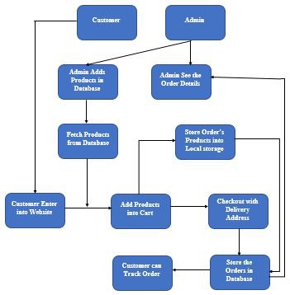

**3.2. DETAILS OF HARDWARE &SOFTWARE**

Project Prerequisites

We will use the following technologies:

1. Front-end technologies:
2. HTML: displays content on web page
3. CSS: creates beautiful styles
4. Bootstrap: html, CSS, and JavaScript framework used to build responsive websites.
5. JavaScript: adding functionality
6. Back-end technologies:
7. Python: programming language.
8. Django framework: web development framework
9. Database Language: MySQL
10. Used Technology: GitHub , VSCode, Xampp
11. Operating System: Windows 7 and above
12. Browser: Any browser and IE 8 and above.
13. Processor: A single-core 2GHz processor
14. RAM: 512 Mb and above

**3.3. APPROACH**

* 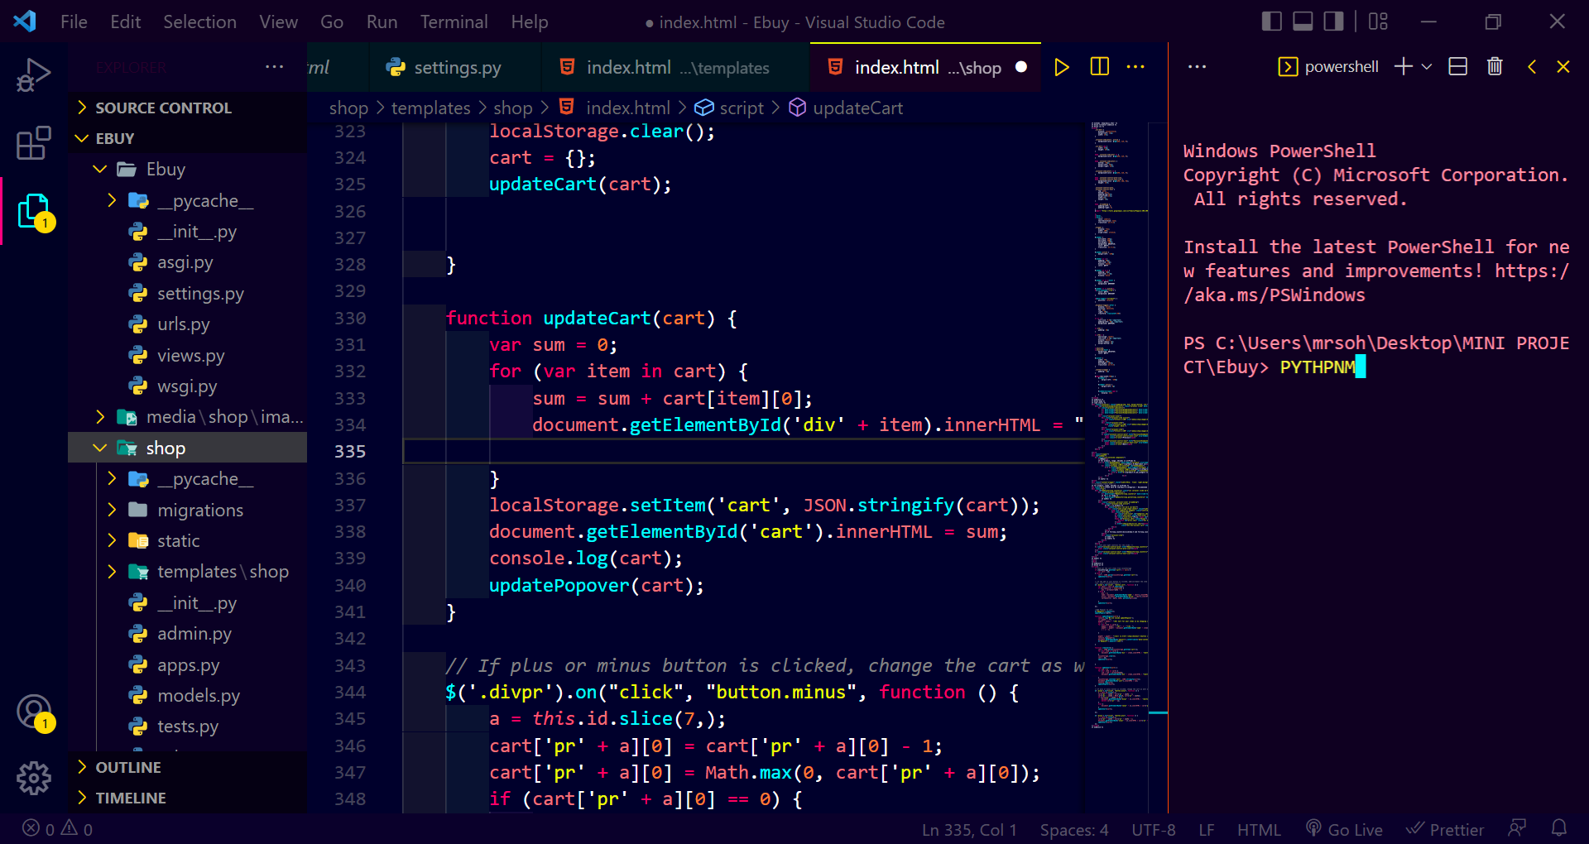Create Normal Project: Open the IDE and create a normal project by selecting File -> New Project.
* Install Django: Next, we will install the Django module from the terminal. We will use PyCharm integrated terminal to do this task. One can also use cmd on windows to install the module by running python -m pip install django command
* Check Installed Django version: To check the installed Django version, you can run the python -m django -version command as shown below.
* Create Django Project: When we execute django-admin startproject command, then it will create a Django project inside the normal project which we already have created here. django-admin startproject ProjectName.
* Check Python3 version: python3 –version
* Run Default Django webserver:- Django internally provides a default webserver where we can launch our applications. python manage.py runserver command in terminal. By default, the server runs on port 8000. Access the webserver at the highlighted URL.

**3.4. DATABASE STRUCTURE**

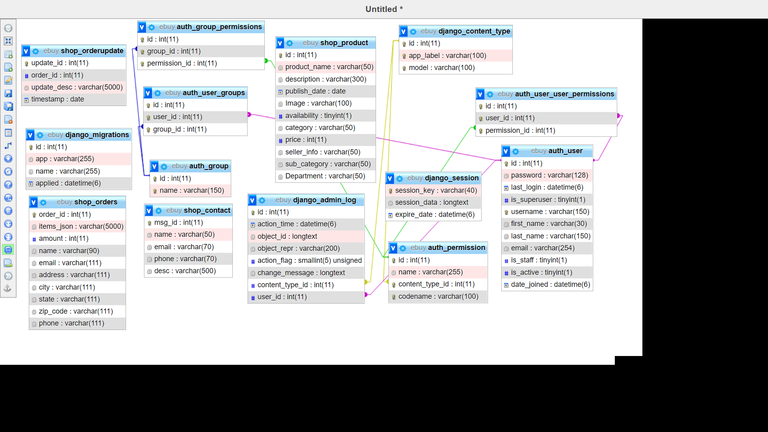

**3.5. ONLINE SHOPPING APPLICATION:**

Anyone can view Online Shopping portal and available products, but every user must login by his/her Username and password in order to purchase or order products. Unregistered members can register by navigating to registration page. Only Admin will have access to modify roles, by default developer can only be an ‘Admin’. Once user register site, his default role will be ‘User’. 6.1 HOMEPAGE: The Home Screen will consist of screen were one can browse through the products which we have on our website

**Web Pages details:**

* Home Page
* AboutUs Page
* productview Page
* ContactUs Page
* Admin Page
* Track
* Checkout Page
* Login Page

3.5.1. **Shop Home Page**

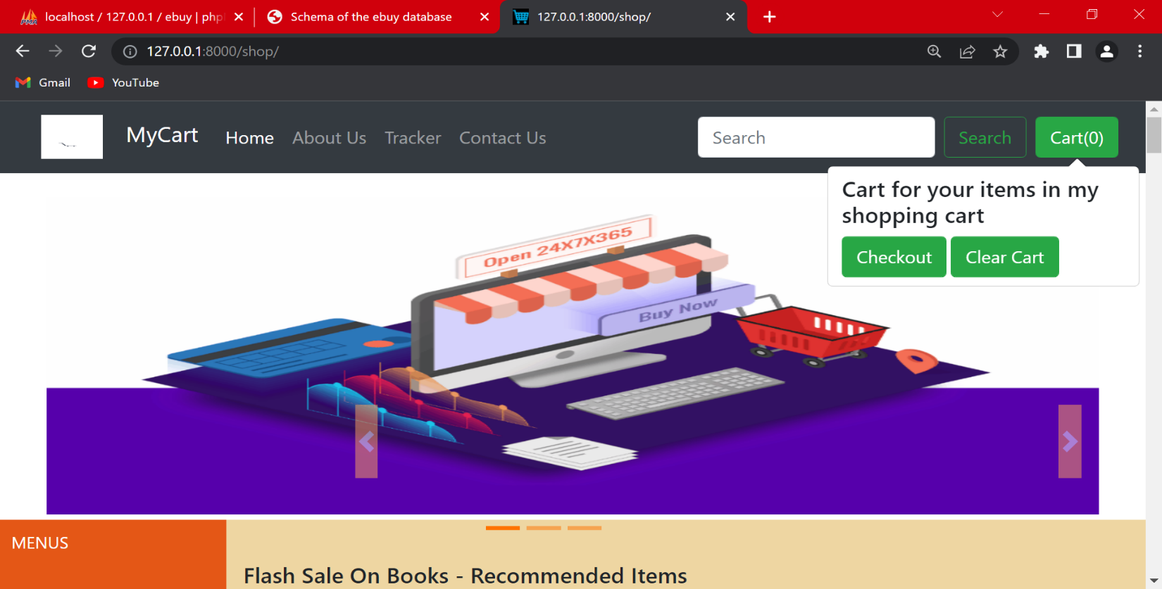

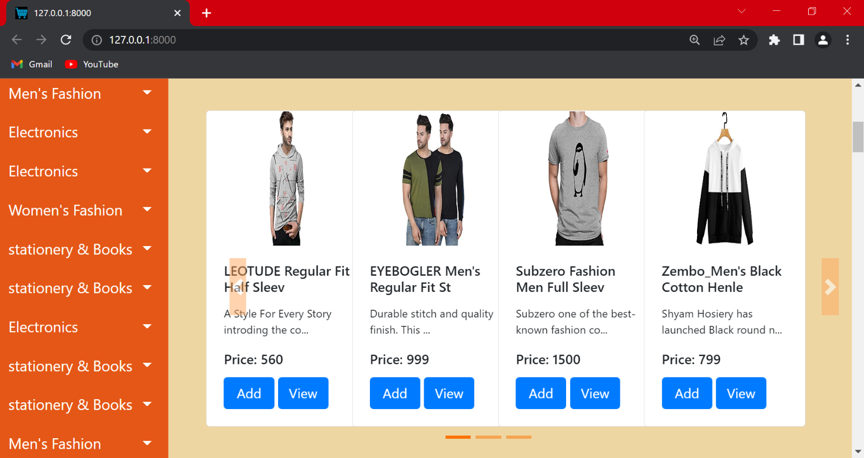

**3.5.2. shop product page:** This page consists of product details. This page appears same for both visitors and users

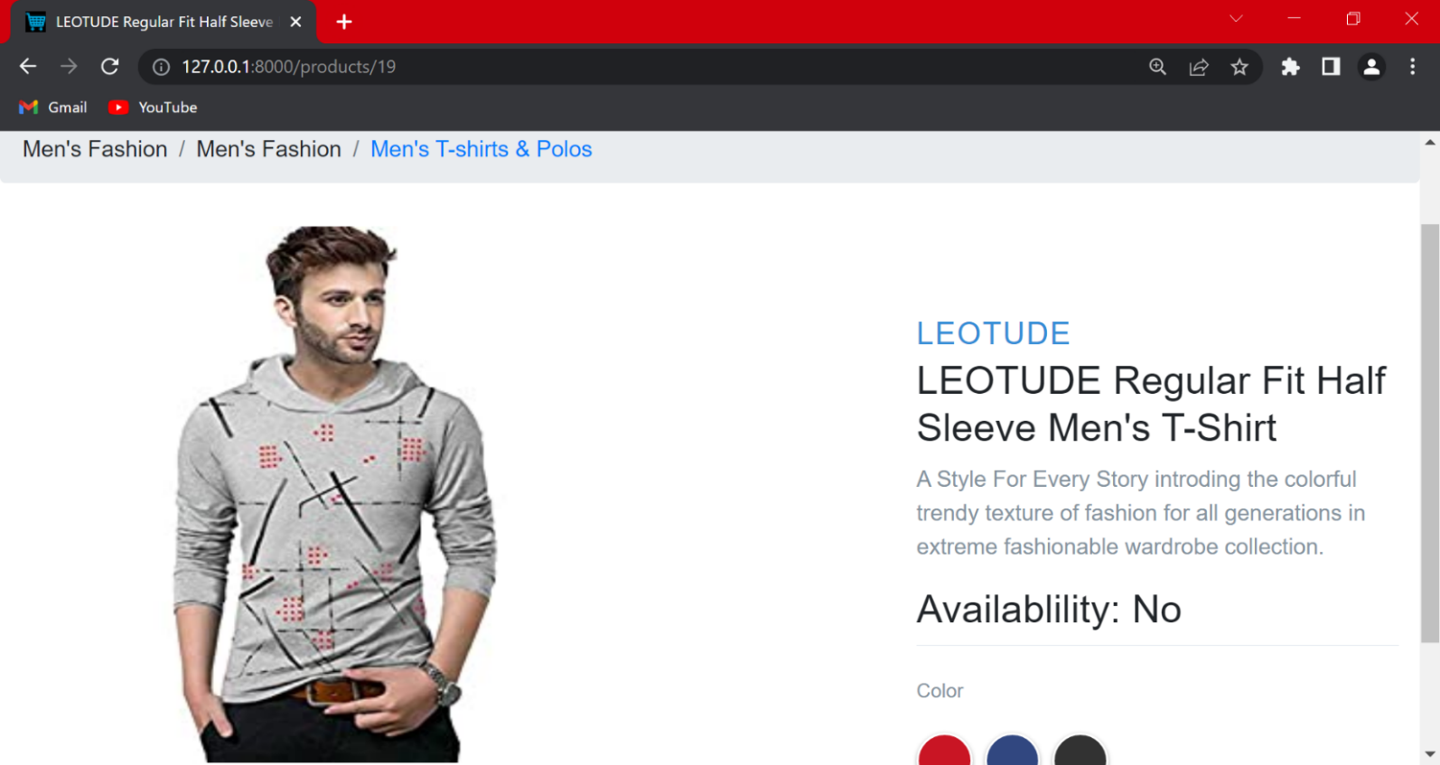

3.5.3. **Shop Track Page**

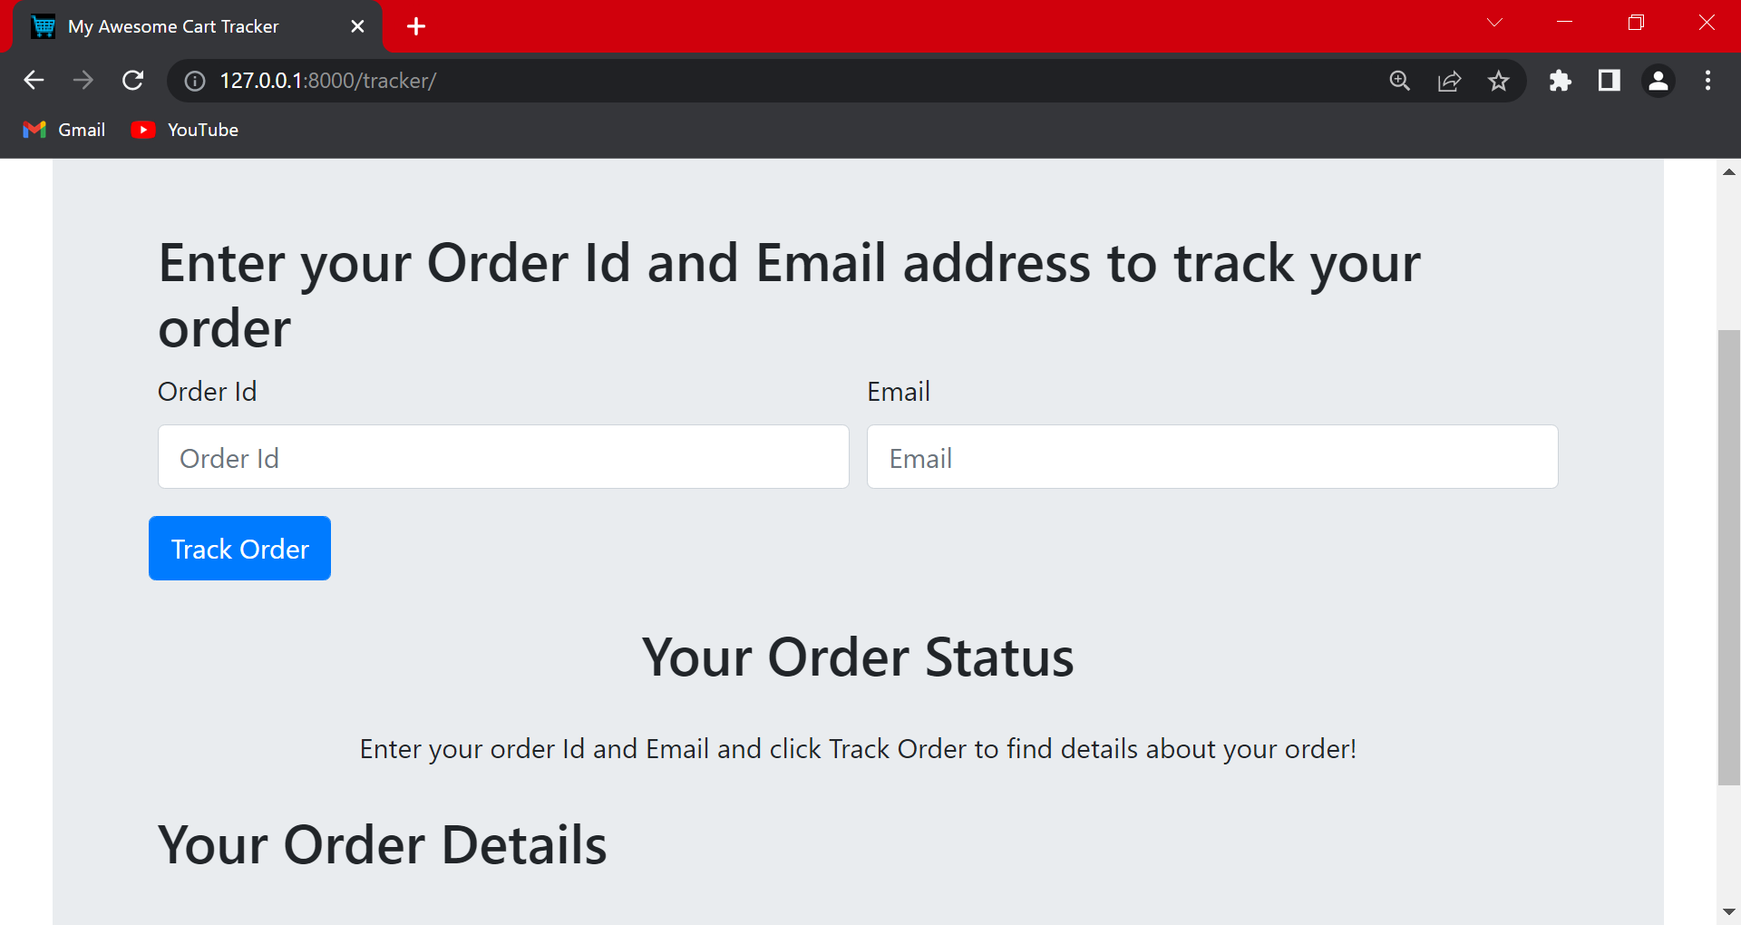

**3.5.4. Contact Us Page:** Visitors and Registered users can contact website owners or administrators from here

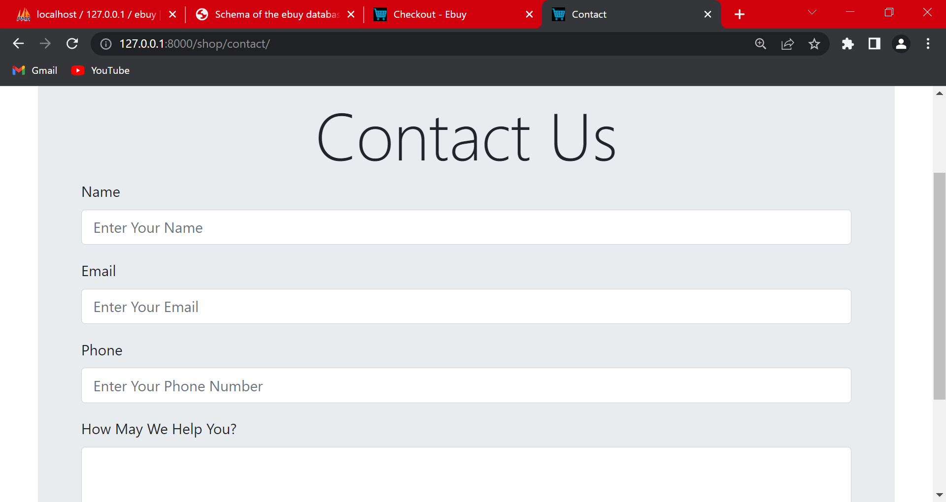

**3.5.5. Shop checkout page**

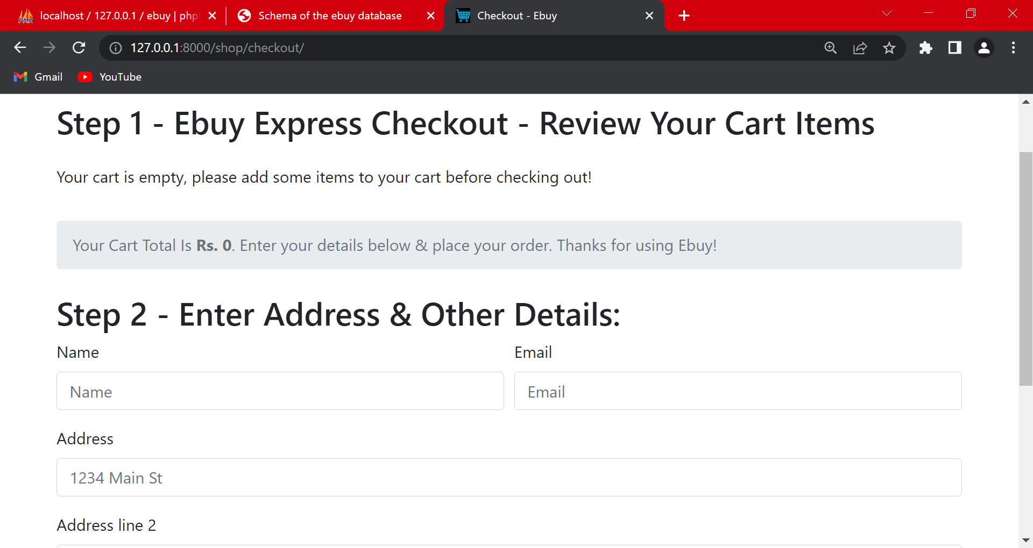

**3.5.6. ABOUT US PAGE:** This page describes about website and owners

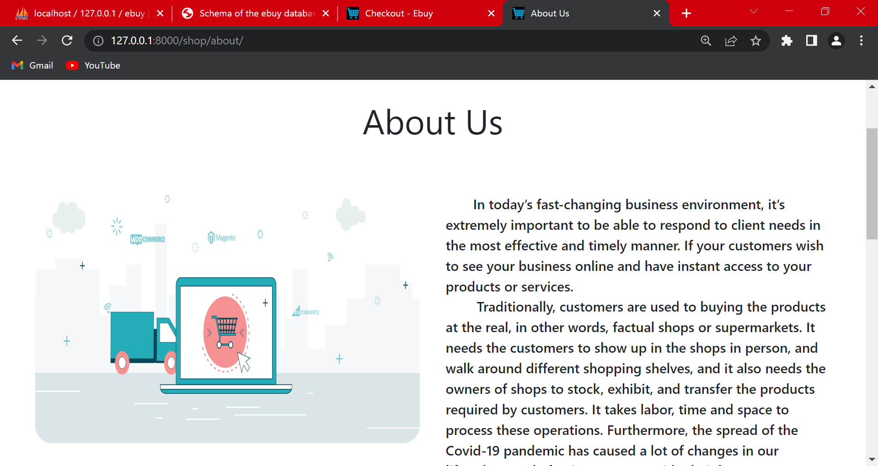

**3.5.7. Admin Page:**

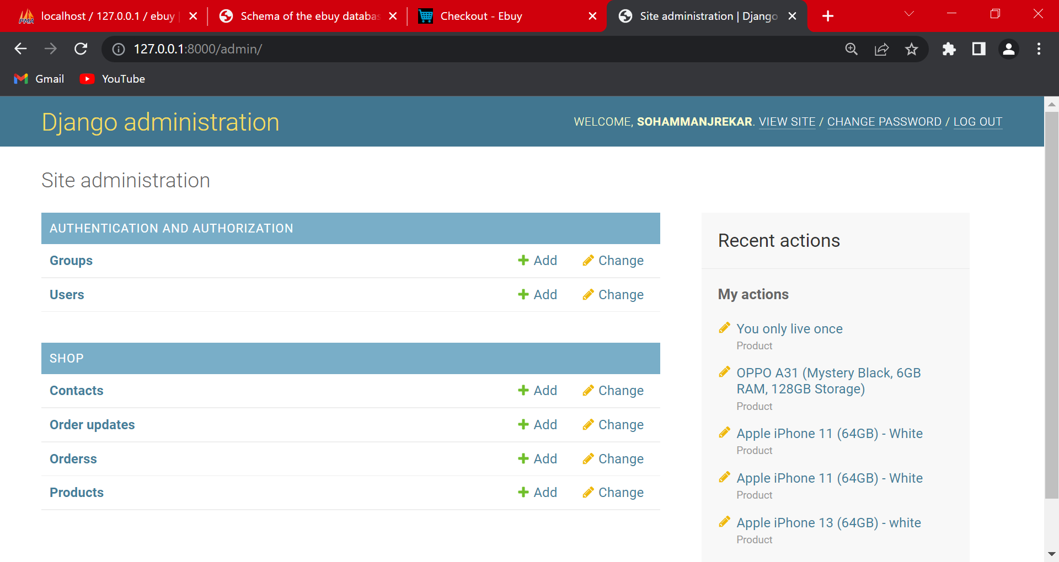

**3.5.8. Login Page:**

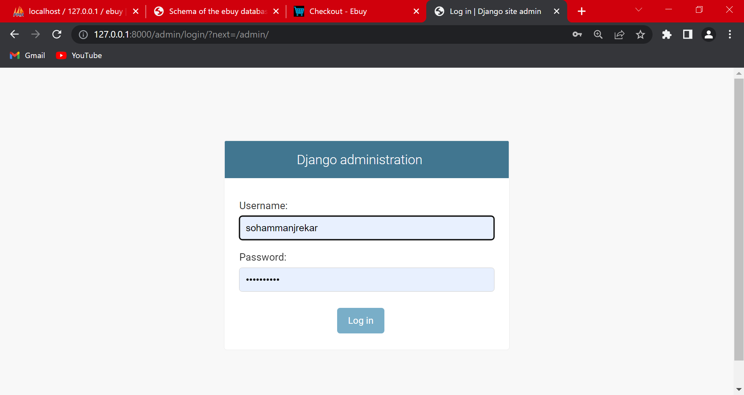

**4) IMPLEMENTATION PLAN**

**4.1. GANTT CHART**

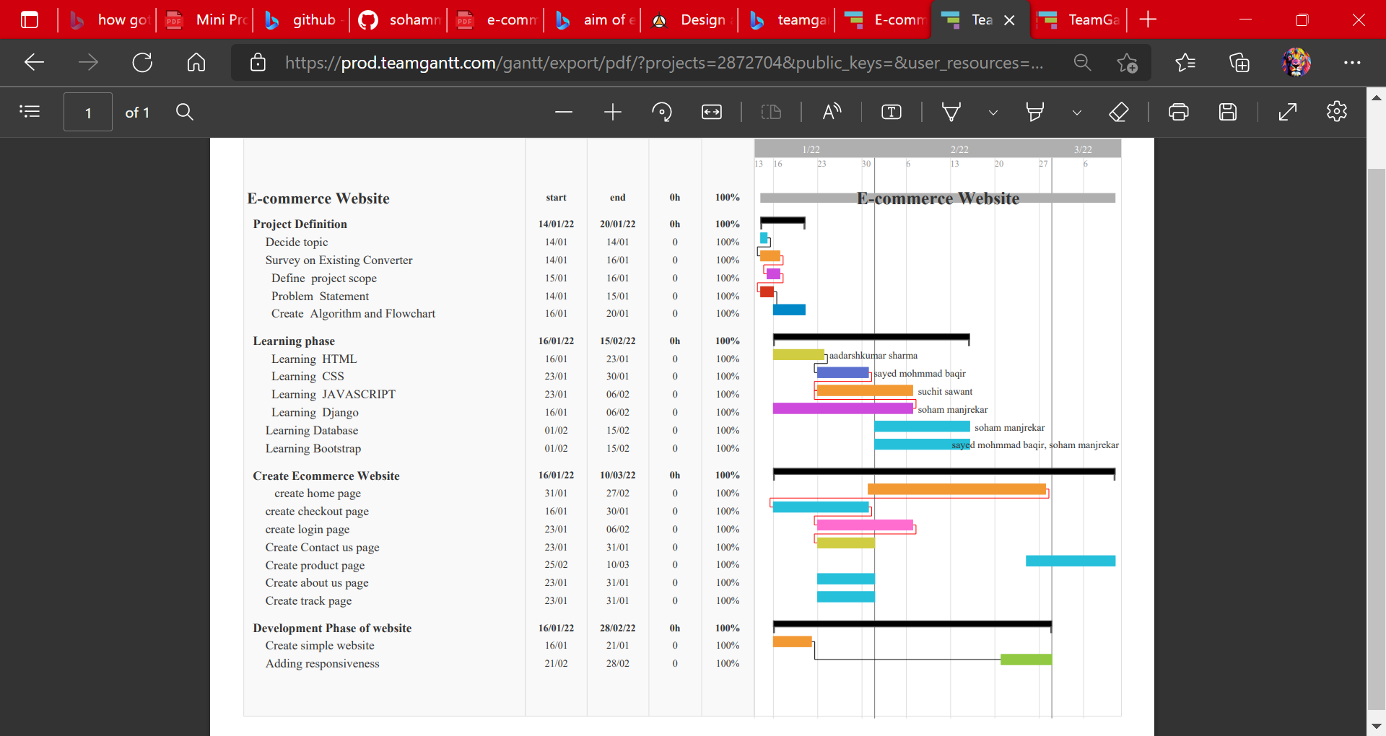

**4.2. COST OF PROJECT**

Cost of project is approx. Rs. 0 because we use free hosting and domain no buy any template or logo. But in future upgrade cost of website is follows:

Domain Name Rs. 199-1000

Website Hosting Rs. 2000-10000

Website Theme Rs. 0-8000

Mobile Responsive Rs. 1000-5000

Logo Rs. 500-6000

Images Rs. 500-2000

**FUTURE SCOPE**

In terms of the future of e-commerce in the 21st century, experts predict promising and wonderful figures. In the foreseeable future, e-commerce will be confirmed as a significant device of sale for the products and enterprises. Successful e-commerce will become the thought which will be inseparable from the web because e-shopping is becoming more and more well-known and normal. In this way, prevailing to future trends, e-commerce will have huge potential development in sales and advancement.

Each year, there is a constant development in e-commerce deals. The volumes of sales for the online store are a lot higher than the block and mortars. To the present day, the internet sales blast the establishment for a magnificent e-commerce future. To draw in more customers, owners won’t just have to increase the number of services available to them yet, in addition, have to give more consideration to such elements like design, great presentation, etc.

**ADVANTAGES OF ECOMMERCE**

**1. A Larger Market**

eCommerce permits you to reach customers everywhere throughout the nation and around the globe. Your customers can make a purchase anywhere and anytime, especially more people are getting used to shopping on their mobile devices.

**2. Customer Insights Through Tracking and Analytics**

Whether you’re sending guests to your eCommerce website through SEO, PPC advertisements or an old-fashioned postcard, there is an approach to follow your traffic and customers’ entire user journey to get bits of knowledge into keywords, user experience, marketing message, valuing strategy, and the sky is the limit from there.

**3. Fast Response to Consumer Trends and Market Demand**

The streamlined coordination’s, especially for merchants who do “outsource,” permit businesses to respond to market and eCommerce trends and consumer demands in a nimble manner. Merchants can likewise create advancements and deals on the fly to pull in customers and generate more sales.

**4. Lower Cost**

With the advance in eCommerce stage technologies, it has become very easy and affordable to set up and keep up an eCommerce store with a low overhead. Merchants no longer have to spend a large budget on TV promotions or announcement, nor stress over the expense for personnel and real estate.

**5. More Opportunities To “Sell”**

Merchants can just provide a limited measure of data on an item in a physical store. Then again, eCommerce websites permit the space to include more data, for example, demo videos, reviews, and customer testimonials to help increase conversion.

**DISADVANTAGES OF E-COMMERCE**

**1. Lack of Personal Touch**

Some consumers value the personal touch they get from visiting a physical store and interacting with sales associates. Such personal touch is especially significant for businesses selling top of the line items as customers need to purchase the merchandise as well as have a great experience during the process.

**2. Lack of Tactile Experience**

Regardless of how well a video is made, consumers despite everything can’t contact and feel an item. Not to mention, it is anything but an easy feat to deliver a brand experience, which could often include the sense of touch, smell, taste, and sound, through the two-dimensionality of a screen.

**3. Price and Product Comparison**

With online shopping, consumers can compare numerous items and locate the lowest price. This forces numerous merchants to compete on price and reduce their overall revenue.

**4. Need for Internet Access**

This is pretty self-evident, however, remember that your customers do need Internet access before they can purchase from you! Since numerous eCommerce stages have features and functionalities that require fast Internet access for ideal customer experience, there’s a chance you’re excluding guests who have moderate connections.

**5. Credit Card Fraud**

Credit card extortion is a real and developing problem for online businesses. It can lead to chargebacks that result in the loss of revenue, penalties, and a terrible reputation

**CONCLUSION**

The project entitled ecommerce website system was completed successfully. The system has been developed with much care and free of errors and at the same time it is efficient and less time consuming. The purpose of this project was to develop a web application for purchasing items from a fashion shop. This project enabled me gain valuable information and practical knowledge on several topics like designing web pages using html & CSS, usage of responsive templates, designing of full stack Django application, and management of database using MySQL. The entire system is secured. Also, the project helped me understanding about the development phases of a project and software development life cycle. I learned how to test different features of a project. This project has given me great satisfaction in having designed an application which can be implemented to any nearby shops or branded shops selling various kinds of products by simple modifications. However, it was very challenging learning and developing an application using a new technology

**ACKNOWLEDGEMENT**

We are extremely thankful to our guide **Prof. Anupam Choudhary** for guidance and review of this paperwork.

**REFERENCES**

1. Python Documentation — <https://docs.python.org/3/>
2. Django Documentation — <https://docs.djangoproject.com/en/3.0/>
3. Git Documentation — <https://git-scm.com/doc>
4. Bootstrap:<https://getbootstrap.com/>